DBMS – LAB -05
NAME : RAHUL VARMA
ROLL NO: S20200010212
SECTION: C
TASK: (LAB EXERCISES)

SQL COMMANDS
1. FUNCTIONS
2. JOINS
QUESTIONS:
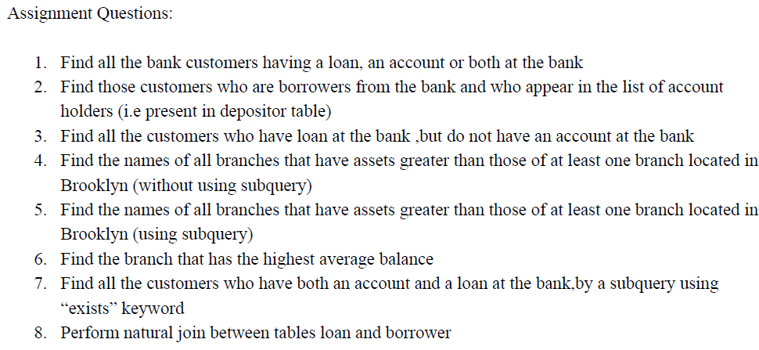
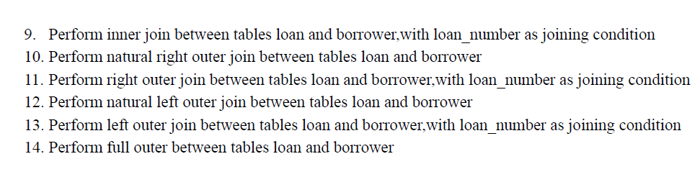
PRACTISE QUESTION :
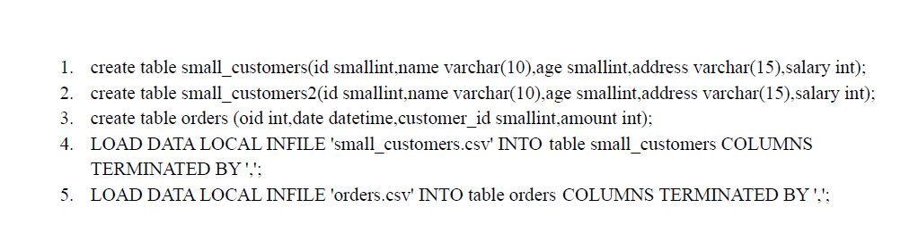

Using small_customers and Orders schema
I created small_customers and Orders table and loaded data into it.

CONTENT IN THE TABLE :

Using Bank Database Schema:

1.Find all the bank customers having a loan, an account or both at the bank

2. Find those customers who are borrowers from the bank and who appear in the list of account holders (i.e present in depositor table)

3. Find all the customers who have loan at the bank ,but do not have an account at the bank

4.Find the names of all branches that have assets greater than those of at least one branch located in Brooklyn (without using subquery)
5. Find the names of all branches that have assets greater than those of at least one branch located in Brooklyn (using subquery)

6. Find the branch that has the highest average balance

7. Find all the customers who have both an account and a loan at the bank,by a subquery using “exists” keyword

8. Perform natural join between tables loan and borrower

9. Perform inner join between tables loan and borrower,with loan_number as joining condition

10. Perform natural right outer join between tables loan and borrower

11. Perform right outer join between tables loan and borrower,with loan_number as joining condition

12. Perform natural left outer join between tables loan and borrower

13. Perform left outer join between tables loan and borrower,with loan_number as joining condition

14. Perform full outer between tables loan and borrower

THANK YOU

